**Statistical analysis for the auxin transport data in two geo-climatically diverged populations of** *A. lyrata***:**

Experiments and data collection by Bishwa

Two different geo-climatically diverge populations of *A. lyrata* are used in this study. NC population – *A. lyrata* ssp. *lyrata* (represents population from average warmer climate with short winter) and Norwegian population – *A. lyrata* ssp. *petrea* (represents population from average cooler climate with long winter). Despite being diverged these two sub species/population can still cross pollinate and establish a viable offspring which makes them a suitable model organisms for evolutionary biology and QTL analyses.

1. We used 3 different individuals from each of the 2 populations (Mayodan – MY, a North Carolinian population; and Spiterstulen – SP, a population from Spiterstulen, Norway).
2. Auxin transport was carried out on 6 different inflorescence samples (3.5-4 cm inflorescence stem around mid-point along the stem) from each individual. **Please follow the excel sheet for data.**
3. 4ul of 3H-IAA was used at 25 Ci/mmol in 1 ml of agar (1.25% wt/vol) to yield a 100 nMol solution.
4. 5ul of the prepared solution at 100 nMol concentration was then transferred at the bottom of 1.5 mL centrifuge tube (6*6 = 36 centrifuge tubes and samples in total were used).
5. Each collected inflorescence sample was then transferred to the prepared centrifuge tube with apical end of the sample submerged in the auxin solution.
6. The auxin transport assay was run for 6 hours (approx.) for each sample which was then transferred to scintillation vial *(after clipping the apical 1 cm part of the sample touching the auxin droplet, retaining the 2 cm of the sample length and discarding the remaining distal part of the sample)* containing 3 ml of scintillation fluid.
7. Instructions (for transport assay in inflorescence) were followed from the protocol (Lewis & Muday, 2009) – Box 1 and Procedure 9 B.
8. **DPM** (Disintegrations per minute) values were measured for quantitative analysis of auxin transport.

**Statistical Analysis (in R-studio)**

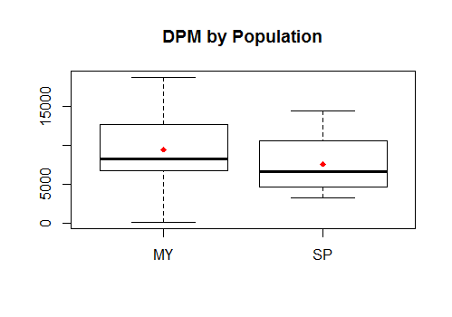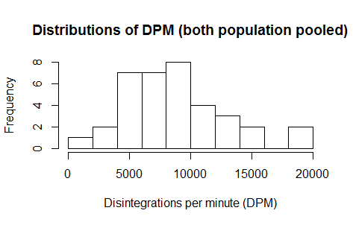

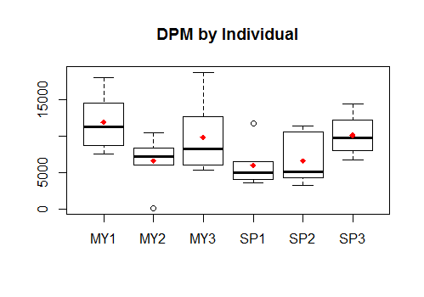

Histogram plot (data pooled for both the population) shows that the combined distribution of DPM is equivalent to normal. Looking at the box plot (*DPM by Population*) the distribution seems more normal (red diamond = mean, black horizontal line = median, for the distribution) in both the population. However, the boxplot (by individual) shows that DPM data is not normally distributed for all the individuals which might be due to smaller sample size with in each individual (6 per individual), with some extreme observations in individuals MY2 and SP1.

**Analysis of Variance:**

> var.test(DPM~POPULATION, data=auxin, alternative = "two.sided", conf.level = 0.95)

**F test to compare variances between data from MY and SP**

data: DPM by POPULATION

F = 1.7542, num df = 17, denom df = 17, **p-value = 0.2566**

alternative hypothesis: true ratio of variances is not equal to 1

95 percent confidence interval:

0.6561778 4.6893975

sample estimates:

ratio of variances

1.75416

F-test to compare the variation of the distribution by population revealed no evidence of difference. (p-value=0.25566) with **ratio of variance = var.MY/var.SP = 1.75416 (95% CI: 0.656 – 4.689)**

**\*\*\*\*\*ANOVA Tests**

**> #ANOVA test for individual level difference for auxin transport or/ DPM**

> fitID <- aov(DPM~Individual, data=auxin)

> summary(fitID)

Df Sum Sq Mean Sq F value **Pr(>F)**

Individual 5 177629504 35525901 2.576 **0.0471** *

Residuals 30 413695601 13789853

---

Signif. codes: 0 ‘***’ 0.001 ‘**’ 0.01 ‘*’ 0.05 ‘.’ 0.1 ‘ ’ 1

Effects at individual levels are significant (at least between two or more individuals, **p-value = 0.0471 ).**

**ANOVA test to compare population level effect (with** *individuals nested within the population***)**

> plot(DPM~SAMPLE, data=auxin, main="Scatter plot: DPM (MY+SP)")

> fit2 <- aov(DPM~POPULATION/Individual, data=auxin)

> summary(fit2)

Df Sum Sq Mean Sq F value Pr(>F)

POPULATION 1 31415128 31415128 2.278 **0.1417**

POPULATION:Individual 4 146214375 36553594 2.651 **0.0525** .

Residuals 30 413695601 13789853

---

Signif. codes: 0 ‘***’ 0.001 ‘**’ 0.01 ‘*’ 0.05 ‘.’ 0.1 ‘ ’ 1

Anova test (population effects with individuals nested within population) showed no significant evidence of difference (or say **weak evidence of difference**) between population; **p-value = 0.141**. Whereas there exists **fair evidence of difference (**almost significant**)** in auxin transport between individuals within the population **(p-value = 0.0525**).

**##******Analysis with the outlier removed*******###**

We observed that the observation (MY2 sample #7) is extreme. We can see for that particular sample the error % for C.E is quite high i.e 20.1, DPM count of 123.1 is equivalent to the background counts (#H) and lumex of 0.11. Thus we suspect that the observation (extreme low value of DPM = 123.1, throughout the distribution) should be a failure, possibly due to distal end of inflorescence sample being dipped in auxin droplet. So, the further analysis is done by removing this observation.

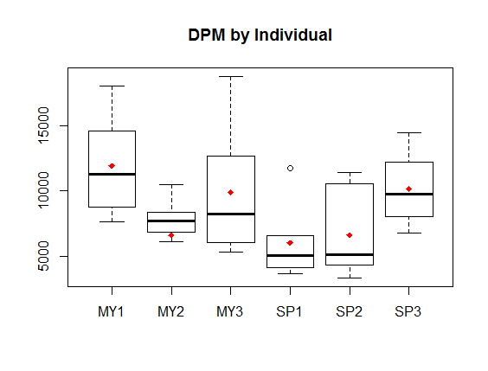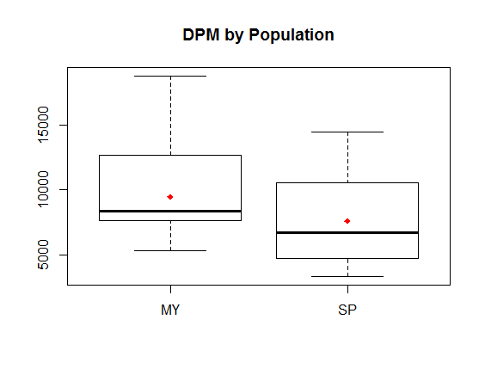

The histogram plot shows that there is almost no difference in distribution after the data for the observation #7 is removed. Box plots (by individuals) show that the pattern of distribution has changed for individual MY2.

**> #ANOVA test for population level difference (with individuals nested within population)**

> fitnewPOPid <- aov(DPM~POPULATION/Individual, data=auxin_trunc)

> summary(fitnewPOPid)

Df Sum Sq Mean Sq F value **Pr(>F)**

POPULATION 1 51127560 51127560 4.082 **0.0527** .

POPULATION:Individual 4 104106096 26026524 2.078 **0.1095**

Residuals 29 363258613 12526159

Signif. codes: 0 ‘***’ 0.001 ‘**’ 0.01 ‘*’ 0.05 ‘.’ 0.1 ‘ ’ 1

F-test reveals fair evidence of difference in auxin transport at the population level, **p-value = 0.0527.** Whereas, there is weak evidence of difference in transport between individuals nested with in the population**, p-value = 0.1095**

The data shows that there exists some evidence of difference in the trends of auxin transport at the population level (with individuals nested with in).

**Summary:**

The Mayodan population (*A. lyrata lyrata*) and Spiterstulen population (*A. lyrata petrea*) both show trend of local adaptation at their respective sites but also variation in quantitative allocation of resources to inflorescence vs. vegetative development (Leinonen et al. 2011). Following that results, our initial hypothesis is that, **“Resource allocation differences between Mayodan and Spiterstulen population is due to the differences in the apical dominance between these two populations”.** Given the smaller sample size in this preliminary experiment; 3 individuals per population, the results suggest there exists differences in the trends of auxin transport between these two populations (though not quite significant at 0.05 level, possibly due to small sample size) which are locally adapted to extremely two different geo-climatic conditions. The observed auxin transport difference in these two populations is consistent with a role of auxin transport in maintaining apical dominance. This result provides ground for further analysis in auxin transport/response differences between populations and how it might be related to resource allocation differences. One thing to note is that **despite thinner inflorescence stem Mayodan population showed greater auxin transport.** We were not able to control for the stem diameter during this preliminary analysis but its straight forward that there is a positive correlation between stem diameter and auxin transport (quadratic if all the transectional area is involved in transport vs. linear if only the epidermal cells are responsible). **This variable can be controlled if the experiment is repeated for validation with greater sample size.**